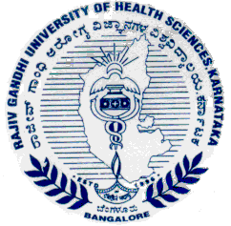

Rajiv Gandhi University of Health Sciences, Karnataka

4th ‘T’ Block, Jayanagar, Bangalore - 560 041
Dr. M K Ramesh Ph: 080 – 26961930, 26961903 Fax: 26961931
Registrar (Evaluation) Email- registrareva@rguhs.ac.in

Reg(E)/Exam/PG/Medical & Dental /Nov- 2018/06 Date: 30/08/2018

ADVANCE NOTIFICATION

Sub: | Conduct of Post Graduate Degree / Diploma Theory Examination during November - 2018.
********

The Post Graduate Degree / Diploma Theory Examination for the below mentioned courses will tentatively commence from 05th November-2018. The detailed Time Table will be notified in due courses.

 | COURSES | DATE
I | MD/MS, PG Diploma, MDS & Diploma | 05th November- 2018

The Principals of the concerned Colleges are requested to notify this on the Notice Board of their colleges for information of the students concerned.

Sd/-

Registrar (Evaluation)
To:
All the Principals of the concerned colleges for information and needful action.

Copy to:

- PA to Vice-Chancellor/Registrar/Finance Officer, RGUHS, Bangalore.
- Deputy Registrar (Admn) section for information and needful action.
- All the officers of the RGUHS, Bangalore.
- Asst. Registrar, Regional Center, Belgaum / Gulbarga.
- Guard File.

